Final Project Instructions

Date Submitted: March 28, 2016

Platform: NOAA Ship Oscar Dyson

Project Number: DY-16-06

Project Title: EcoFOCI Spring Moorings

Project Dates: 03 May – 14 May 2016

Prepared by: ________________________ Dated: __________________
Dr. Peter d’Urphee Proctor
Chief Scientist
NOAA-PMEL/JISAO

Approved by: ________________________ Dated: __________________
Dr. Phyllis Stabeno
Program Lead, EcoFOCI
NOAA-PMEL

Approved by: ________________________ Dated: __________________
Dr. Christopher L. Sabine
Director
NOAA-PMEL

Approved by: ________________________ Dated: __________________
Commander Brian Parker, NOAA
Commanding Officer
Marine Operations Center – Pacific

I. Overview
A. EcoFOCI Spring Moorings; May 03 – May 14, 2016
B. Days at Sea (DAS)
Of the 12 DAS scheduled for this project, 0 DAS are funded by an OMAO allocation, 12 DAS are funded by a Line Office Allocation, 0 DAS are Program Funded, and 0 DAS are Other Agency funded. This project is estimated to exhibit a High Operational Tempo.
C. Operating Area
Eastern Bering Sea - map shown below:
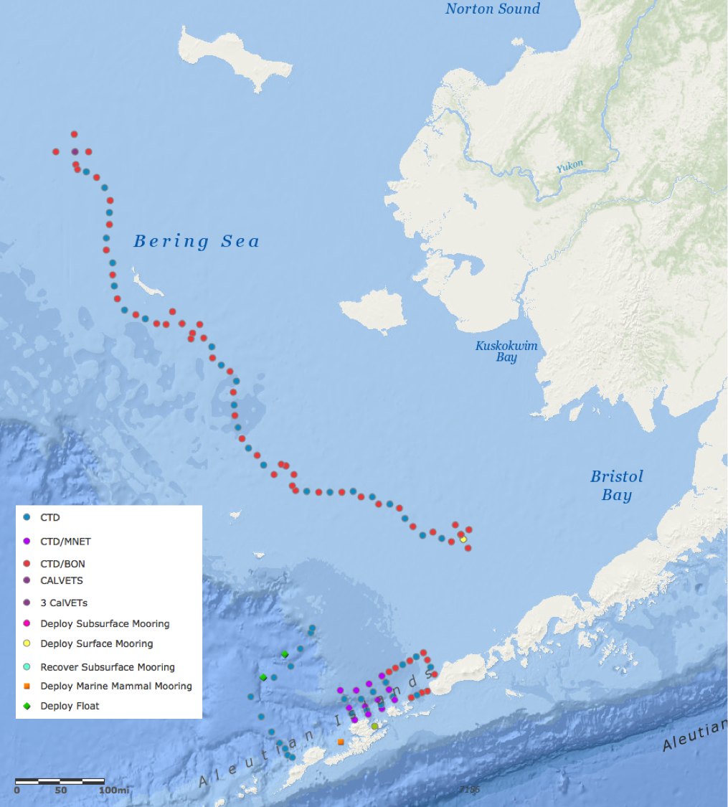
D. Summary of Objectives
The project is intended to perform hydrographic and zooplankton studies in the Bering Sea; recover 2 subsurface moorings and redeploy one subsurface and two surface moorings at the same location. An additional project will be to test the operation of a towed hydrographic instrument.

The ship will depart Dutch Harbor and transit to Unimak Pass and commence the CTD grid referred to as the Unimak Box.
The ship will then proceed to Site 2 to recover the two subsurface moorings and deploy two surface moorings and a subsurface mooring. Additionally a series of CTDs, bongo tows and CalVETs will be conducted in a box around the mooring site. These will be done either before or after the mooring operations depending upon the weather and time of day when we arrive at the site.
Leaving Site 2 the ship will then proceed north along the 70m isobath, conducting CTDs, CalVETs and bongos per the attached list, as far north as the ice permits.
During the transit south from the northernmost CTD station on the 70m isobath, we will test the operation of the towed vehicle.
Further CTD sampling will be conducted as time permits along the “Dog Leg Line” and at stations adjacent to the Aleutian Islands in the vicinity of Unalaska Island.
The ship will deploy two Argo Drifters in 2000-meter water along the “Dog Leg Line”.
A Marine Mammal Mooring (M³) will be deployed off Umnak Island.

E. Participating Institutions
NOAA - Pacific Marine Environmental Laboratory (PMEL)
7600 Sand Point Way N.E., Seattle, Washington 98115-6439

Joint Institute for the Study of the Atmosphere and Oceans (JISAO)
University of Washington
3737 Brooklyn Ave. NE
Seattle, WA 98105-6715

NOAA - Alaska Fisheries Science Center (AFSC)
7600 Sand Point Way N.E., Seattle, Washington 98115-0070

University of Alaska (UAF)
505 South Chandalar Drive
Fairbanks, AK 99775
F. Personnel/Science Party: name, title, gender, affiliation, and nationality

Name (Last, First) | Title | Date Aboard | Date Disembark | Gender | Affiliation | Nationality
Peter Proctor | Chief Sci. | 04/30/2016 | 05/15/2016 | M | JISAO/PMEL | USA
Geoff Lebon | Sci. | 04/30/2016 | 05/15/2016 | M | PMEL | USA
Lisa Eisner | Sci. | 05/01/2016 | 05/14/2016 | F | JISAO/PMEL | USA
Mike Canino | Sci. | 05/01/2016 | 05/14/2016 | M | AFSC | USA
Kim Martini | Sci. | 05/01/2016 | 05/14/2016 | F | JISAO/PMEL | USA
Melanie Paquin | Sci. | 05/01/2016 | 05/14/2016 | F | AFSC | USA
Michael Craig | Sci. | 05/01/2016 | 05/14/2016 | M | PMEL | USA
Daniel Naber | Sci. | 05/01/2016 | 05/15/2016TBD | M | UAF | USA
* these personnel have not been chosen at this time.
G. Administrative
1. Points of Contacts:
Peter Proctor (Chief Scientist), JISAO/PMEL, 7600 Sand Point Way NE, Bldg 3, Seattle WA 98115-0070, ph: (206) 526-6217; Peter.Proctor@NOAA.GOV
Janet Duffy-Anderson, AFSC, 7600 Sand Point Way NE, Bldg 4, Seattle, WA 98115, ph: (206) 526-6465; Janet.Duffy-Anderson@NOAA.GOV
Phyllis Stabeno, PMEL, 7600 Sand Point Way NE, Bldg 3, Seattle, WA 98115-0070; ph: (206) 526-6453; Phyllis.Stabeno@NOAA.GOV
LT Carl Rhodes (Operations Officer NOAA Ship Oscar Dyson), NOAA Corps, 2002 SE Marine Science Dr., Newport, OR, 97365, ph: (541) 867-8911; ops.oscar.dyson@NOAA.GOV
2. Diplomatic Clearances
None Required.
3. Licenses and Permits
None Required.
II. Operations
The Chief Scientist is responsible for ensuring the scientific staff are trained in planned operations and are knowledgeable of project objectives and priorities. The Commanding Officer is responsible for ensuring all operations conform to the ship’s accepted practices and procedures.
A. Project Itinerary:
Departure: Tuesday, May 3, 2016, Dutch Harbor, AK
Arrive: Saturday, May 14, 2016, Dutch Harbor, AK
B. Loading and Unloading:
Two containers with equipment will be shipped directly from Seattle to Dutch Harbor; loading onboard ship will occur as appropriate prior to departure. The scientific party will arrive at least two days early to assist with loading and preparation. They will be responsible for arranging vehicles for transporting themselves and equipment to the ship. At the end of the project recovered mooring equipment and other equipment that will not be needed later in the field season will remain on board to be off-loaded at the end of the following project, in Dutch Harbor, for shipment to Seattle. To facilitate pre-project equipment assembly and set up, a crane operator will be needed during the normal day work hours on May 3.
Additional assistance will be needed from engineering and deck force personnel to mount the winch for the towed vehicle on the after deck and install a block on the after A-frame for the towed vehicle cable.
Additional mooring equipment will be shipped from University of Alaska, Fairbanks, to Dutch Harbor for loading on the ship.
C. Operations to be conducted:
Due to the time of year that this project occurs, the amount of mooring work accomplished and the sequence of operations will depend heavily upon ice conditions, weather and daylight. Decisions on which operations to be conducted will be made on a daily basis in consultation with the ship’s command and Chief Scientist and based upon conditions and priorities. A full list of Station IDs including locations is provided as Appendix I.
The ship is scheduled to depart Dutch Harbor on Tuesday, May 3, 2016.
- Unimak Box CTDs: CTDs will be taken at each of 18 stations in a “box” around Unimak Pass. At each station within the pass a 20/60 cm bongo will be towed and at every other station on the sides and top of the box for the collection of mesozooplankton.
- FOCI Bering Site 2: Depending upon arrival time the project will commence mooring operations or the CTD “box” around the site. Two subsurface moorings will be recovered and a subsurface and two surface moorings will be deployed. Calibration CTDs will be taken prior to recovery of the moorings and subsequent to the deployment of the new moorings approximately 0.25 nautical miles (nm) from the mooring site. Each CTD will consist of one or two casts depending upon requirements for sampling which will include nutrient and chlorophyll samples. Additionally a 20/60 cm bongo tow and triplicate CalVET tows will be conducted at the calibration site. At four stations around Site 2 a CTD and 20/60 cm bongo tow will be completed.
- 70 Meter Isobath Line: A CTD cast with sampling for salinity, chlorophyll, nutrients and oxygen will be taken at each station along the 70-meter isobath. A 20/60 cm bongo tow will be conducted at every other station. Stations will commence at Site 2 and continue as far north as ice, weather and time permits. CTDs will be to within 5 meters of the bottom.
- FOCI Bering Sea Moorings, Sites 4, 5 & 8: If weather and ice conditions permit access to these mooring sites we will conduct CTD, bongo and CalVET sampling at the mooring sites and on the box around the moorings.
- “Dog Leg” Line: Up to 11 CTD stations may be sampled if time permits. Locations are in Appendix I. CTD casts will be to within 5 meters of the bottom or 1500 meters
- Drifter Deployments: Two Argo drifters will be deployed on the “Dog Leg Line” in water over 2000 meters deep and preferably more than 20 nm from water shallower than 2000 meters. The floats in their box weigh 110 pounds and can be launched by two or three persons; no lifting equipment will be required. Appendix 1, contains the locations of previous deployments to use for planning purposes, these locations are not mandatory. Appendix IV contains further information about the drifters/floats and their deployment.
- Marine Mammal Mooring: an acoustic sensor mooring for the detection of marine mammals – whales – will be deployed off Umnak Island.
- Bering Canyon CTD Transects: A CTD will be deployed at each of 15 stations (5 stations/3 lines). A Multinet will be deployed at 3 stations per line (9 Multinet stations total).
- Unimak Box W Transect: A second occupation of the Unimak Box W transect will be done as time permits. A CTD will be deployed at each of 5 stations; a Multinet will be deployed at 3 stations. Additional sampling with CTD and bongos will be done in the Unimak Box as time permits.
- Acrobat Towed Vehicle: Testing of the new Acrobat Towed Vehicle will be conducted while transiting south along the 70m isobath after completion of CTDs along the 70m isobath.
- Multinet: A Multinet (see Appendix V, midi size) will be deployed at select stations (locations listed in Appendix I). The Multi Plankton Sampler, MultiNet Type Midi, will be used at select stations to determine vertical distribution of fish larvae and zooplankton (.333 or .505-mm mesh). The sampling will be focused over Bering Canyon at approximately 12 stations. The exact number and location will be determined by the scientific party at sea and may be adjusted depending on conditions and project priorities.
We request assistance from the ship’s Electronics Technician, Survey Technician and / or Deck Department as needed to help set up the electronic and physical termination, rig the MultiNet for fishing, and help trouble shoot the MultiNet. We also request help switching between the Bongo and MultiNet on the aft hydrographic winch as needed during the project.
The MultiNet has a steel frame with a square mouth opening of .5 x .5 m that can be used with up to 5 nets to sample different water depths. This net requires a conducting cable and will be deployed off the aft hydrographic winch that the Bongo array is usually attached to. Before deployment of the Multinet, the SeaCAT and Bongo array will be detached and the MultiNet will be electronically and physically terminated to that conducting wire. For the stations over Bering Canyon, the MultiNet will be used in place of the Bongo (after the CTD). If we have gear problems with the Multinet, the Bongo will be used as a backup. When we are done using the MultiNet, the SeaCAT and Bongo Array will be re-connected to continue the rest of our routine sampling. The MultiNet plankton samples will be processed in a similar manner as those from the Bongo, filtered and preserved in 1.8% Buffered Formaldehyde.

Winch / Fishing Rates
-Ship Speed: ~2.5-3 knots (may need to be adjusted based on conditions)
-Wire Payout Rate: 20 m per. min.
-Wire Retrieval Rate: no more than 10 m per min., possibly slower TDB by scientific party based on how much water is being filtered.
-Target Wire Angle 55° (acceptable range 50°-60°)
-Maximum Gear Depth: ~ 300 m or 10m off bottom

MOA Buttons Needed for SCS
-In the water (surface)
-At Depth
-Net 1
-Net 2
-Net 3
-Net 4
-Net 5
-Out of the water (surface)

Approximate Sampling Intervals (may change depending on bottom depth and sampling needs):
0-25 m
25-50 m
50-100 m
100-200 m
200-300 m
- Primary production: Experiments using stable (non-radioactive) isotopes (15N and 13C) will be conducted at a subset of stations. Water samples will be collected from Niskin bottles, isotope added, then incubated in a deck-board clear plastic tank cooled with surface seawater. At end of incubation, samples will be filtered and filters stored frozen at -20°C or colder.
- The order of operations may change due to weather or the presence of sea ice.

D. Dive Plan
All dives are to be conducted in accordance with the requirements and regulations of the NOAA Diving Program (http://www.ndc.noaa.gov/dr.html) and require the approval of the ship’s Commanding Officer

Dives are not planned for this project.

E. Applicable Restrictions

Conditions that preclude normal operations: Poor weather, equipment failure, unforeseen conditions and ice coverage would all preclude normal operations. Poor weather would have to be waited out or the project track would have to be modified to provide the best weather possible. A-frame or winch failures would need to be addressed immediately for the project to continue. Ice coverage would negate the ability to pop moorings; these would have to be recovered later in the project (depending on ice forecasts) or by another vessel.
III. Equipment
A. Equipment and Capabilities provided by the ship (itemized)
• Hydrographic winch with slip rings and 3-conductor cable terminated for CTD,
• 12 KHz hull mounted Edgetech Acoustic release transducer,
• Hydrographic winch with slip rings and 3-conductor cable terminated for the SBE19plus for net tow operations,
• Sea-Bird Electronics’ SBE 911plus CTD system with stand and dual Temperature and Conductivity sensors, each CTD system should include underwater CTD, weights, and pinger. There should be a deck unit for the system,
• 5 or 10-liter Niskin sampling bottles for use with rosette (10 plus 4 spares); we request that at least 6 of the 10-liter bottles have silicon tubing springs rather than the black rubber springs which interferes with some of the experiments.
• Conductivity and temperature sensor package to provide dual sensors on the CTD (primary),
• For meteorological observations: 2 anemometers (one R. M. Young system interfaced to the SCS), calibrated air thermometer (wet-and dry-bulb) and a calibrated barometer and/or barograph,
• Freezer space for storage of biological and chemical samples (blast and storage freezers, -20° C and -80°C), turned on and operating,
• SIMRAD ES-60 and EK-60 echosounders,
•
• Scientific Computer System (SCS),
• Minimum of 2 computer workstations in the acoustic lab with Internet, printer and e-mail access,
• Removable stern platform (in place),
• Laboratory space with storage space,
• Underway flow-through seawater system with TSG
• Seawater hoses and nozzles to wash nets,
• Adequate deck lighting for nighttime operations,
• Navigational equipment including GPS and radar,
• Safety harnesses for working on quarterdeck and fantail,
• Ship’s crane(s) used for loading and/or deploying.

B. Equipment and Capabilities provided by the scientists (itemized)
• Sea-Bird Electronics’ SBE-19plus SEACAT system,
• Fluorometer, light meter and dual oxygen sensors to be mounted on CTD,
• Conductivity and temperature sensor package to provide dual sensors on the CTD (backup),
• 60-cm bongo sampling arrays,
• 20 cm bongo sampling arrays,
• Manual wire angle indicator,
• CalVET net sampling array,
• Hydro-BIOS Multinet (midi) sampling system,
• Towed vehicle and winch, to be mounted on the after deck,
• Surface mooring, doughnut buoy and instruments, and anchor,
• Subsurface mooring, floats, instruments and anchor,
• ITAE (Innovative Technology for Arctic Exploration) mooring, buoy, instruments, and anchor,
• Marine Mammal mooring, floats, instruments and anchor,
• Equipment as needed to drag for moorings that fail to release,
• Miscellaneous scientific sampling and processing equipment,
• Chlorophyll and nutrient sampling equipment,
• Clear plastic incubator (modified aquarium) ~ 4’x 2’x 2’ cooled with surface seawater for primary production experiments. It will be used on deck in an uncovered area with surface seawater available.
• Ocean Drifters—Argo, (2)
• Winkler Oxygen Analysis rig,
• pCO2 system installed in flow-through system,
•

IV. Hazardous Materials
A. Policy and Compliance
The Chief Scientist is responsible for complying with FEC 07 Hazardous Materials and Hazardous Waste Management Requirements for Visiting Scientific Parties (or the OMAO procedure that supersedes it). By Federal regulations and NOAA Marine and Aviation Operations policy, the ship may not sail without a complete inventory of all hazardous materials by name and quantity, MSDS, appropriate spill cleanup materials (neutralizing agents, buffers, or absorbents) in amounts adequate to address spills of a size equal to the amount of chemical brought aboard, and chemical safety and spill response procedures. The Chief of Operations, Marine Operations Center, will provide documentation regarding those requirements upon request.
Per OMAO procedure, the scientific party will include with their project instructions and provide to the CO of the respective ship 30 days before departure:
    - List of chemicals by name with anticipated quantity
    - List of spill response materials, including neutralizing agents, buffers, and absorbents
    - Chemical safety and spill response procedures, such as excerpts of the program’s Chemical Hygiene Plan or SOPs relevant for shipboard laboratories
    - For bulk quantities of chemicals in excess of 50 gallons total or in containers larger than 10 gallons each, notify ship’s Operations Officer regarding quantity, packaging and chemical to verify safe stowage is available as soon as chemical quantities are known.
Upon embarkation and prior to loading hazardous materials aboard the vessel, the scientific party will provide to the CO or their designee:
- An inventory list showing actual amount of hazardous material brought aboard
- An MSDS for each material
- Confirmation that neutralizing agents and spill equipment were brought aboard sufficient to contain and cleanup all of the hazardous material brought aboard by the program
- Confirmation that chemical safety and spill response procedures were brought aboard
Upon departure from the ship, scientific parties will provide the CO or their designee an inventory showing that all chemicals were removed from the vessel. The CO’s designee will maintain a log to track scientific party hazardous materials. MSDS will be made available to the ship’s complement, in compliance with Hazard Communication Laws.
Scientific parties are expected to manage and respond to spills of scientific hazardous materials. Overboard discharge of hazardous materials is not permitted aboard NOAA ships.

B. Inventory

Chemicals were loaded on the Dyson 1/20 /2016 by FOCI and MACE personnel; all chemicals listed will be used for the entire 2016 Dyson field season. Chemical volumes will be reported to the Ops Officer and the designated contact for each survey will be required to report to chemical owners. The name of the group responsible for each of the chemicals is designated after the chemical name in the table. MSDS, chemical hygiene plan, and SOPs will be provided to Dyson before the loading of the vessel.

Common Name | Concentration | Amount | Spill Response (all FOCI/MACE/PMEL/EMA personnel) | Notes
Dihydrogen Monoxide  Note: this may be replaced by the ship’s installed system  Property of PMEL |  | 25 liters | Spill Control: W  Gloves  Paper towels | Not a regulated chemical/solution.  Used for oxygen titrations.  Store in Chem Lab or Salinometer room
Ethanol  Property of FOCI | 100% | 4 -1 gal. Plastic jugs | Gloves  3M Sorbent Pads  Plastic bag | Store in Chem. Lab yellow flammables cabinet.
Ethylene Glycol  Property of FOCI | 100% | 1 – 500 ml | Gloves  Paper towels  Plastic bag | Not a regulated chemical. Store in Spill Kit.
Formaldehyde  Property of FOCI | 37% | 5 – 5 gal. barrels | Gloves  Eye Protection  Fan-Pads  Formalex  PolyForm-F  Plastic bags | Store in Fish Lab flammable cabinets. Will need to place 2-3 in each cabinet.
Formaldehyde  Property of Sandi Neidetcher | 37% | 8 – 1 liter plastic bottles | Gloves  Eye Protection  Fan-Pads  Formalex  PolyForm-F  Plastic bag | Store in Fish Lab flammable cabinet.
Formaldehyde  Property of Troy Buckley | 37% | 16– 1 liter plastic bottles | Gloves  Eye Protection  Fan-Pads  Formalex  PolyForm-F  Plastic bag | Store in Fish Lab flammable cabinet.
Glycerol/Thymol Solution  Property of MACE | 50 % | 2 – 5 gal. buckets | Gloves  Paper towels  Kitty litter | Not a regulated chemical/solution.  Store in Fish Lab under sink.
Lithium 3v Batteries  Property of FOCI |  | 9 | NA | Store in Survey Office for Spring Mooring Multi-Net use
Lithium 9v Batteries  Property of PMEL |  | 8 | NA | In SeaBird and WET Lab instruments
Lithium AA Batteries  Property of PMEL |  | 96 | NA | In SeaBird instruments and MicroCAT Saft LS14500
Lithium D Cell Batteries  Property of PMEL |  | 150 | NA | In RCM9 & Peggy Mooring
Lithium Transponder Batteries  Property of MACE |  | 3 | NA | Avoid heat and moisture during storage. MACE will provide storage container.
Manganese Chloride  Property of PMEL | 3M | 1 liter |  | Not a regulated chemical/solution.  Used for oxygen titrations.  Working volume will be secured on CTD hanger counter.  Store in Chem Lab acid locker
Potassium Iodate  Property of PMEL | 0.00167 M | 1 liter | Spill Control: PI  Gloves  Plastic bag | Used for oxygen titrations.  Store in Chem Lab acid locker
Sodium Borate Solution  Property of FOCI | 5-6% | 1 – 5 gal. | Gloves  Paper towels  Plastic bag | Not a regulated chemical. Working container will be secured on Fish Lab counter.
Sodium Borate Powder  Property of FOCI | 100% | 1 – 500 g | Gloves  Wet paper towels  Plastic bag | Not a regulated chemical. Stored in Spill Kit.
Sodium Iodide/NaOH Solution  Property of  PMEL | 0.11M | 1 liter | Spill Control: B | Used for oxygen titrations.  Working volume will be secured on CTD hanger counter.  Store in Fish Lab flammable cabinet.
Sodium Thiosulfate  Property of PMEL | 0.11 M | 1 liter | Spill Control: ST | Used for oxygen titrations.  Store in Chem Lab acid locker
Sulfuric Acid  Property of PMEL | 5 M | 1 liter | Spill Control: A | Used for oxygen titrations.  Store in Chem Lab acid locker

12N Hydrochloric Acid  Property of FOCI | 12N | 0.5 liters | Spill Control A | For use in cleaning productivity experiment equipment  Store in Acid locker in Chem Lab
Compressed Air  Property of UAF |  | 1 tank (roughly the size of dive tanks) | N/A | Calibration gas used in the CO2 system on the surface buoy
Mercuric Chloride  Property of UAF |  | 0.25L | See ‘M’ below
Lithium D Cell Batteries  Property of UAF | 9 |  |  | In SeaCAT instrument packages on the moorings

- Chemical safety and spill response procedures

Formaldehyde Spill Kit Contents | Amount | Use | Total Spill Volume Controllable | Notes
Formalex | 1 – 5 gallon  2 -1 gallon | Formaldehyde cleanup (all concentrations) | 1:1 control | Formalex will be used in conjunction with Fan-Pads to reduce spill volume.
Fan-Pads | 2 rolls (50 sheets each roll) | Formaldehyde cleanup (all concentrations) | 50 sheets = 50 - 150 ml spills | Formalex will be used in conjunction with Fan-Pads to reduce total spill volume.
PolyForm-F | 5 – 1 gal. plastic jugs | Formaldehyde cleanup (all concentrations) | 1:1 control | Pour onto spill immediately to deactivate formaldehyde.
3 M Pads | 10 pads | Ethanol cleanup | 10 pads=10- 250ml spills | Pads may be reused if dried out under fume hood.
Nitrile Gloves | 8 pairs each S,M,L,XL | For all cleanup procedures | N/A | Each survey group will restock gloves.
Eye Protection | 4 pairs goggles  1 face shield | Formaldehyde cleanup | N/A | Eye protection will be cleaned before re-use.
Tyvex Lab Coats | 2 coats | Formaldehyde cleanup | N/A | Coats will be cleaned with Fan-Pads and Formalex before reuse.
Plastic Bags | 2 | Formaldehyde cleanup/Fan Pads | N/A | Bags may be packed full and sealed.

Acid-Base Spill Kit Contents | Amount | Use | Total Spill Volume Controllable | Notes
Spilfyter Acid Neutralizer | 1 box | Clean up acid spill—H₂SO₄ | 1.5l of 5M Sulfuric Acid  5.57l of 10% (1N) HCl
Spilfyter Base Neutralizer | 1 box | Clean up base spill--NaOH | 2.0l of Sodium Hydroxide
Vinyl Gloves | 1 box | Protect hands during cleanup | N/A
Foxtail/Dustpan | 1 each | Pick up absorbed neutralizer | N/A
Rubber apron | 1 each | Protect during cleanup | N/A
Paper Towels | 1 roll | Absorb liquids | N/A
Goggles | 2 pair | Protect eyes | N/A
Chemical absorbent | 1 liter | Absorb liquids | 0.5l
Plastic Bags | 2 each | Contain used absorbents/waste | N/A

Inventory of Mercury Spill Kit supplies:
Product Name | Amount | Chemicals it is useful against | Amount it can clean up
Mercury eater | 1.8kg | Mercuric Chloride/Mercury | .5L
Goggles | 1 pair | All | N/A
Plastic Bags | 5 | All – for used absorbents | Varies
Final Wipes | 50 | Mercuric Chloride/Mercury | N/A
Kolorsafe Base | 2.5 lbs | Bases | 1L
Latex Gloves | 2 pair | All | N/A
Broom | 1 ea | All | N/A
Baking soda | 2.5lbs | Acids | 1L

SPILL CONTROL

A: ACID
· Wear appropriate protective equipment and clothing during clean up. Keep upwind. Keep out of low areas.
· Ventilate closed spaces before entering them.
· Stop the flow of material, if this is without risk. Dike the spilled material, where this is possible.
· Large Spills: Dike far ahead of spill for later disposal. Use a non-combustible material like vermiculite, sand or earth to soak up the product and place into a container for later disposal.
· Small Spills: Wipe up with absorbent material (e.g. cloth, fleece). Clean surface thoroughly to remove residual contamination.
· Never return spills in original containers for re-use.
· Neutralize spill area and washings with soda ash or lime. Collect in a non-combustible container for prompt disposal.
· J. T. Baker NEUTRASORB® acid neutralizers are recommended for spills of this product.

B: Base
· Wear appropriate protective equipment and clothing during clean up. Keep upwind. Keep out of low areas.
· Ventilate closed spaces before entering them.
· Neutralize with dilute acid such as HCl if possible.
· Absorb with cat litter or vermiculite.
· Vacuum or sweep up material and place into suitable disposal container.
· Do not breathe dust.
· Do not get water on spilled substances.

F: Formalin/Formaldehyde
· Ventilate area of leak or spill. Remove all sources of ignition.
· Wear appropriate personal protective equipment.
· Isolate hazard area. Keep unnecessary and unprotected personnel from entering. Contain and recover liquid when possible.
· Use non-sparking tools and equipment. Collect liquid in an appropriate container or absorb with an inert
material (e. g., vermiculite, dry sand, earth), and place in a chemical waste container.
· Do not use combustible materials, such as sawdust.

M: Mercury
· Spills: Pick up and place in a suitable container for reclamation or disposal in a method that does not generate dust. Sprinkle area with sulfur or calcium polysulfide to suppress mercury. Use Mercury Spill Kit if need be.

PI: Potassium Iodate
· Wear appropriate protective equipment and clothing during clean-up.
· Avoid Contact with combustibles (wood, paper, clothing, etc).
· Absorb with cat litter or vermiculite.
· Keep substance damp with water spray.
· Vacuum or sweep up material and place into suitable disposable container (plastic bag).

ST: Sodium Thiosulfate
· Ventilate area of leak or spill.
· Wear protective gloves and clean body-covering
· Use chemical safety goggles. Maintain eye wash fountain and quick-drench facilities in work area.
· Recover liquid or particulate in 5-gallon bucket. Absorb with a kitty litter and place in disposable bag.
Do
not use combustible materials, such as sawdust to absorb.

W: Water
· Absorb the liquid and wash with water
· Wear PPE

E: Ethanol
· Ventilate area of leak or spill. Remove all sources of ignition.
· Wear appropriate personal protective equipment.
· Isolate hazard area. Keep unnecessary and unprotected personnel from entering. Contain and recover
liquid when possible.
· Use non-sparking tools and equipment. Collect liquid in an appropriate container or absorb with an inert
material (e. g., vermiculite, dry sand, earth), and place in a chemical waste container.
· Do not use combustible materials, such as sawdust.
Chemical Hygiene Plan and Standard Operating Procedures (SOPs)
Chemical Hygiene Plan

Previous sections of the Project Instructions include a list of hazardous materials by name and anticipated quantity. Chemicals will be transported, stored and used in a manner that will avoid any spills and adequate containment; absorbents and cleanup materials will be available in the event of a chemical spill.

Standard Operating Procedures and Information Sheets are provided here for the scientific chemicals. Included are details concerning personal protective equipment, work area precautions, special handling and storage requirements, spill and accident procedures/first aid, waste disposal and other pertinent information. Both small and large spills are of particular concern. In both cases, the spill response is intended to first contain the spill and then neutralize it. This may be easily accomplished for small spills depending on the degree of vessel motion and the prevailing environmental conditions. In all cases, the first responder should quickly evaluate the risks of personal exposure versus the potential impacts of a delayed response to the spill and act accordingly. For example, if the spill is small and it is safe to do so, a neutralizing agent should be rapidly applied to encircle/contain the spill and then cover it. However, a large formaldehyde spill (> 1 L) is extremely hazardous and individuals at risk of exposure should immediately leave the area. The CO or OOD should be notified immediately so that a response team with self-contained breathing apparatus (SCBA) can be deployed to complete the cleanup operation or dispense the hazard with a fire hose directed overboard. The vessel’s course should be adjusted to minimize exposure of personnel to wind-driven vapors and to limit spread of the spill due to vessel motion. The reportable quantity (RQ) of formaldehyde is 1,000 pounds and the RQ for ethyl alcohol is 5,000 pounds which greatly exceed the quantities brought aboard for this project.

Standard Operating Procedures – Formaldehyde At-Sea
Chemical Name: 37% Formaldehyde
UN Number: 1198
Hazard Ratings: (on a scale of 0 to 4)
Health (blue): 3 Flammability (red): 2
Reactivity (yellow): 2 Special (white):
Personal Protection Gear Needed
*gloves
*goggles or face shield
Special Handling Instructions
* If a ventilation hood is not available, then pouring of chemical must be done outside. At least two people should be involved with large chemical transfers in case of an emergency.
* Chemical must be stored at temperatures above 15º c to prevent polymerization of paraformaldehyde.
First Aid
* If swallowed, give large amounts of drinking water and induce vomiting.
*If vapors inhaled, get out into fresh air immediately. Give oxygen if breathing is difficult.
* If spilled on skin or splashed in eyes, flush with water for at least 15 minutes.
Spill Cleanup Procedures
For small spills (500-1000 ml):
Cover spill quickly with a Fan Pad and spray on Formalex to deactivate and absorb chemical. Let material sit for 10 - 15 minutes. Dispose of materials in plastic bag.
For large spills (>1000 ml):
Use a combination of Fan Pads and Formalex as quickly as possible to contain spill and deactivate it. Vacate area and try to ventilate room, if possible. Call Bridge immediately.
Deactivation/Disposal Procedures At Sea
*Formalex is a greenish liquid that is to be used to insure proper chemical deactivation. Formalex should also be used in conjunction with Fan Pads. Place used Fan Pad in plastic bag, seal, and put in bottom of Spill Kit.
*Fan Pads may be used to absorb small spills alone but these pads work best when used with Formalex to immediately control the vapor layer.
Shipping Procedures and Restrictions
37% formaldehyde cannot be ship by air due to its flammability rating.
All quantities should be over-packed with absorbency material in case the original container is damaged. When shipping by barge or land, labels are not required for quantities under 110 gallons by D.O.T. but the container should have MSDS and the UN number readily available.

Standard Operating Procedures – Ethanol At-Sea

3

0
2

Chemical Name: 100% Alcohol
UN Number: 1170
Hazard Ratings: (on a scale of 0 to 4)
Health (blue): 2 Flammability (red): 3
Reactivity (yellow): 1 Special (white):
Personal Protection Gear Needed
*gloves
*goggles or face shield when pouring
Special Handling Instructions
* Keep away from heat, flame, and other potential ignition sources.
* Store in a well-ventilated area or in a flammable cabinet.
First Aid
* If swallowed, give large amounts of drinking water and induce vomiting.
* If vapors inhaled, get out into fresh air immediately. Give oxygen if breathing is difficult.
* If spilled on skin or splashed in eyes, flush with water for at least 15 minutes.
Spill Cleanup Procedures
Absorb ethanol with 3M Sorbent Pads and allow to dry in a well-ventilated area away from ignition source.
Deactivation/Disposal Procedures At Sea
Use 3M Sorbent Pads to absorb the ethanol. Put used pads outside to dry (secure from blowing overboard and exposure to flame). Once dry, the pads may be reused or burned.
Shipping Procedures and Restrictions
Due to the flammability rating of 95% ethanol, this chemical cannot be shipped by air. Transportation by barge or land vehicle will require the ethanol container to be over-packed with absorbent materials such as clumping kitty litter or shredded paper. Include MSDS and the UN number with the shipment for reference in the event of a spill.

- Radioactive Materials
No radioactive isotopes are planned for this project.
V. Additional Projects

- Supplementary (“Piggyback”) Projects

No supplementary projects are planned.

- NOAA Fleet Ancillary Projects

No NOAA fleet ancillary projects are planned.

VI. Disposition of Data and Reports

Disposition of data gathered aboard NOAA ships will conform to NAO 216-101 Ocean Data Acquisitions and NAO 212-15 Management of Environmental Data and Information. To guide the implementation of these NAOs, NOAA’s Environmental Data Management Committee (EDMC) provides the NOAA Data Documentation Procedural Directive (data documentation) and NOAA Data Management Planning Procedural Directive (preparation of Data Management Plans). OMAO is developing procedures and allocating resources to manage OMAO data and Programs are encouraged to do the same for their Project data.
- Data Classifications:

  - OMAO Data

  - Program Data - At the end of the project, the Chief Survey Technician will provide the Chief Scientist with copies of data from the ship’s SCS system, barometer measurements, log sheets, TSG data, rain sensor data, wind speed and direction data, ship’s navigation log data, speed logs, winch system, Fluorometer data, and any other logged scientific data. The number of copies of each data set will be worked out between the Chief Scientist and Chief Survey Technician.

- Responsibilities: Chief Scientist will distribute data to Program Principle Investigators as appropriate.

VII. Meetings, Vessel Familiarization, and Project Evaluations

- Pre-Project Meeting: The Chief Scientist and Commanding Officer will conduct a meeting of pertinent members of the scientific party and ship’s crew to discuss required equipment, planned operations, concerns, and to establish mitigation strategies for all concerns. This meeting shall be conducted before the beginning of the project with sufficient time to allow for preparation of the ship and project personnel. The ship’s Operations Officer usually is delegated to assist the Chief Scientist in arranging this meeting.

- Vessel Familiarization Meeting: The Commanding Officer is responsible for ensuring scientific personnel are familiarized with applicable sections of the standing orders and vessel protocols, e.g., meals, watches, etiquette, drills, etc. A vessel familiarization meeting shall be conducted in the first 24 hours of the project’s start and is normally presented by the ship’s Operations Officer.

- Post-Project Meeting: The Commanding Officer is responsible for conducting a meeting no earlier than 24 hrs before or 7 days after the completion of a project to discuss the overall success and shortcomings of the project. Concerns regarding safety, efficiency, and suggestions for future improvements shall be discussed and mitigations for future projects will be documented for future use. This meeting shall be attended by the ship’s officers, applicable crew, the Chief Scientist, and members of the scientific party and is normally arranged by the Operations Officer and Chief Scientist.

- Project Evaluation Report: Within seven days of the completion of the project, a Customer Satisfaction Survey is to be completed by the Chief Scientist. The form is available at http://www.omao.noaa.gov/fleeteval.html and provides a “Submit” button at the end of the form. Submitted form data is deposited into a spreadsheet used by OMAO management to analyze the information. Though the complete form is not shared with the ships, specific concerns and praises are followed up on while not divulging the identity of the evaluator.

VIII. Miscellaneous

- Meals and Berthing

The ship will provide meals for the scientists listed above. Meals will be served three times daily beginning one hour before scheduled departure, extending throughout the project, and ending two hours after the termination of the project. Since the watch schedule is split between day and night, the night watch may often miss daytime meals and will require adequate food and beverages (for example a variety of sandwich items, cheeses, fruit, milk, juices) during what are not typically meal hours. Special dietary requirements for scientific participants will be made available to the ship’s command at least seven days prior to the project.

Berthing requirements, including number and gender of the scientific party, will be provided to the ship by the Chief Scientist. The Chief Scientist and Commanding Officer will work together on a detailed berthing plan to accommodate the gender mix of the scientific party taking into consideration the current make-up of the ship’s complement. The Chief Scientist is responsible for ensuring the scientific berthing spaces are left in the condition in which they were received; for stripping bedding and linen return; and for the return of any room keys that were issued. The Chief Scientist is also responsible for the cleanliness of the laboratory spaces and the storage areas utilized by the scientific party, both during the project and at its conclusion prior to departing the ship.

All NOAA scientists will have proper travel orders when assigned to any NOAA ship. The Chief Scientist will ensure that all non-NOAA or non-Federal scientists aboard also have proper orders. It is the responsibility of the Chief Scientist to ensure that the entire scientific party has a mechanism in place to provide lodging and food and to be reimbursed for these costs in the event that the ship becomes uninhabitable and/or the galley is closed during any part of the scheduled project.

All persons boarding NOAA vessels give implied consent to comply with all safety and security policies and regulations which are administered by the Commanding Officer. All spaces and equipment on the vessel are subject to inspection or search at any time. All personnel must comply with OMAO's Drug and Alcohol Policy dated May 17, 2000, which forbids the possession and/or use of illegal drugs and alcohol aboard NOAA Vessels.

- Medical Forms and Emergency Contacts

The NOAA Health Services Questionnaire (NHSQ, NF 57-10-01 (3-14)) must be completed in advance by each participating scientist. The NHSQ can be obtained from the Chief Scientist or the NOAA website http://www.corporateservices.noaa.gov/noaaforms/eforms/nf57-10-01.pdf.
All NHSQs submitted after March 1, 2014 must be accompanied by NOAA Form (NF) 57-10-02 - Tuberculosis Screening Document in compliance with OMAO Policy 1008 (Tuberculosis Protection Program).
The completed forms should be sent to the Regional Director of Health Services at the applicable Marine Operations Center. The NHSQ and Tuberculosis Screening Document should reach the Health Services Office no later than 4 weeks prior to the start of the project to allow time for the participant to obtain and submit additional information should health services require it, before clearance to sail can be granted. Please contact MOC Health Services with any questions regarding eligibility or completion of either form. Ensure to fully complete each form and indicate the ship or ships the participant will be sailing on. The participant will receive an email notice when medically cleared to sail if a legible email address is provided on the NHSQ.
The participant can mail, fax, or email the forms to the contact information below. Participants should take precautions to protect their Personally Identifiable Information (PII) and medical information and ensure all correspondence adheres to DOC guidance (http://ocio.os.doc.gov/ITPolicyandPrograms/IT_Privacy/PROD01_008240).
The only secure email process approved by NOAA is Accellion Secure File Transfer which requires the sender to setup an account. Accellion’s Web Users Guide is a valuable aid in using this service, however to reduce cost the DOC contract doesn’t provide for automatically issuing full functioning accounts. To receive access to a “Send Tab”, after your Accellion account has been established send an email from the associated email account to accellionAlerts@doc.gov requesting access to the “Send Tab” function. They will notify you via email usually within 1 business day of your approval. The ‘Send Tab” function will be accessible for 30 days.
Contact information:

Regional Director of Health Services
Marine Operations Center – Pacific
2002 SE Marine Science Dr.
Newport, OR 97365
Telephone 541-867-8822
Fax 541-867-8856
Email MOP.Health-Services@noaa.gov

Prior to departure, the Chief Scientist must provide an electronic listing of emergency contacts to the Executive Officer for all members of the scientific party, with the following information: contact name, address, relationship to member, and telephone number.

- Shipboard Safety

Hard hats are required when working with suspended loads. Work vests are required when working near open railings and during small boat launch and recovery operations. When hard hats and work vests are required, they will be provided by the ship.

Wearing open-toed footwear or shoes that do not completely enclose the foot (such as sandals or clogs) outside of private berthing areas is not permitted. At the discretion of the ship CO, safety shoes (i.e. steel or composite toe protection) may be required to participate in any work dealing with suspended loads, including CTD deployment and recovery. The ship does not provide safety-toed shoes/boots. The ship’s Operations Officer should be consulted by the Chief Scientist to ensure members of the scientific party report aboard with the proper attire.

D. Communications

A progress report on operations prepared by the Chief Scientist may be relayed to the program office. Sometimes it is necessary for the Chief Scientist to communicate with another vessel, aircraft, or shore facility. Through various means of communications, the ship can usually accommodate the Chief Scientist. Special radio voice communications requirements should be listed in the project instructions. The ship’s primary means of communication with the Marine Operations Center is via e-mail and the Very Small Aperture Terminal (VSAT) link. Standard VSAT bandwidth at 128kbs is shared by all the vessel’s staff and the science team at no charge. Increased bandwidth in 30-day increments is available on the VSAT systems at increased cost to the scientific party. If increased bandwidth is being considered, program accounting is required, and it must be arranged at least 30 days in advance.

E. IT Security

Any computer that will be hooked into the ship's network must comply with the OMAO Fleet IT Security Policy 1.1 (November 4, 2005) prior to establishing a direct connection to the NOAA WAN. Requirements include, but are not limited to:
(1) Installation of the latest virus definition (.DAT) file on all systems and performance of a virus scan on each system.
(2) Installation of the latest critical operating system security patches.
(3) No external public Internet Service Provider (ISP) connections.
Completion of these requirements prior to boarding the ship is required.
Non-NOAA personnel using the ship's computers or connecting their own computers to the ship's network must complete NOAA’s IT Security Awareness Course within three days of embarking.

F. Foreign National Guests Access to OMAO Facilities and Platforms

Foreign National access to the NOAA Ship or Federal Facilities is not required for this project.

Appendix I: Station list

Note: the locations for the CalVETs and CTD/BON on the locations of the moorings are the actual locations of the moorings; CalVETs and CTDs should be approximately 0.25 nm from the location of the moorings, Bongos adjusted accordingly.

CTD casts will be to 5 meters from the bottom or 1500 meters max.

 | Sta Name | Activity | Water Depth (m) | Lat.dd | Lon.dd
 | Depart Dutch Harbor | DEPART |  | 53.881 | 166.432
Unimak Box
 | UBS1 | CTD/BON | 42 | 54.441 | 164.985
 | UBS2 | CTD/BON | 110 | 54.419 | 165.141
 | UBS3 | CTD | 203 | 54.375 | 165.277
 | UBS4 | CTD/BON | 91 | 54.342 | 165.429
 | UBW1 | CTD/BON | 91 | 54.358 | 165.929
 | UBW2 | CTD/BON | 511 | 54.472 | 166.039
 | UBW3 | CTD | 402 | 54.583 | 166.129
 | UBW4 | CTD/BON | 329 | 54.688 | 166.237
 | UBN1 | CTD/BON | 183 | 54.751 | 166.051
 | UBN2 | CTD/BON | 168 | 54.813 | 165.858
 | UBN3 | CTD | 153 | 54.868 | 165.671
 | UBN4 | CTD/BON | 139 | 54.930 | 165.480
 | UBN5 | CTD | 124 | 54.987 | 165.287
 | UBN6 | CTD/BON | 110 | 55.049 | 165.107
 | UBE1 | CTD/BON | 88 | 54.937 | 164.996
 | UBE2 | CTD | 67 | 54.827 | 164.894
 | UBE3 | CTD/BON | 46 | 54.716 | 164.784
BS Site 2 | 15BS-2C | Recover Subsurface  Mooring | 70 | 56.871 | 164.066
 | 15BSP-2B | Recover Subsurface  Mooring | 70 | 56.878 | 164.0685
 | 16BSM-2A | Deploy Surface Mooring | 70 | 56.8 | 164.0
 | ITAE | Deploy Surface Mooring | 70 | 56.8 | 164.0
 | 16BSP-2A | Deploy Subsurface Mooring | 70 | 56.8 | 164.0
 | 70M2/M2 | 3 CalVETs | 72 | 56.871 | 164.066
 | 70M2/M2 | CTD/BON | 72 | 56.871 | 164.066
 | CTD -M2N | CTD/BON | 69 | 57.017 | 164.217
 | CTD - M2E | CTD/BON | 69 | 56.942 | 163.834
 | CTD -M2S | CTD/BON | 72 | 56.667 | 163.867
 | CTD - M2W | CTD/BON | 75 | 56.767 | 164.333
70 m isobath
 | 70M3 | CTD | 73 | 56.808 | 164.583
 | 70M4 | CTD/BON | 72 | 56.909 | 164.828
 | 70M5 | CTD | 73 | 56.859 | 165.123
 | 70M6 | CTD/BON | 72 | 56.994 | 165.378
 | 70M7 | CTD | 70 | 57.107 | 165.613
 | 70M8 | CTD/BON | 70 | 57.262 | 165.747
 | 70M9 | CTD | 70 | 57.321 | 166.011
 | 70M10 | CTD/BON | 70 | 57.322 | 166.326
 | 70M11 | CTD | 70 | 57.438 | 166.513
 | 70M12 | CTD/BON | 70 | 57.429 | 166.812
 | 70M13 | CTD | 70 | 57.522 | 167.038
 | 70M14 | CTD/BON | 71 | 57.499 | 167.344
 | 70M15 | CTD | 72 | 57.501 | 167.665
 | 70M16 | CTD/BON | 71 | 57.501 | 167.986
 | 70M17 | CTD | 79 | 57.520 | 168.304
 | 70M18 | CTD/BON | 78 | 57.524 | 168.614
 | 70m19-M4S | CTD/BON | 75 | 57.600 | 168.700
 | CTD - M4E | CTD/BON | 74 | 57.767 | 168.667
 | 70M21/M4 | 3 CalVETs | 73 | 57.890 | 168.872
 | 70M21/M4 | CTD/BON | 73 | 57.890 | 168.872
 | 70M22 - M4W | CTD/BON | 71 | 57.767 | 169.200
 | CTD - M4N | CTD/BON | 71 | 57.917 | 169.000
 | 70M23 | CTD | 70 | 57.907 | 169.500
 | 70M24 | CTD/BON | 69 | 58.042 | 169.673
 | 70M25 | CTD | 71 | 58.147 | 169.918
 | 70M26 | CTD/BON | 72 | 58.282 | 170.095
 | 70M27 | CTD | 73 | 58.446 | 170.186
 | 70M28 | CTD/BON | 72 | 58.617 | 170.276
 | 70M29 | CTD | 71 | 58.774 | 170.294
 | 70M30 | CTD/BON | 72 | 58.948 | 170.327
 | 70M31 | CTD | 69 | 59.107 | 170.247
 | 70M32 | CTD/BON | 68 | 59.247 | 170.412
 | 70M33 | CTD | 70 | 59.335 | 170.656
 | 70M34 | CTD/BON | 81 | 59.436 | 170.906
 | 70M35 | CTD | 80 | 59.595 | 170.923
 | 70M36 | CTD/BON | 79 | 59.716 | 171.140
 | 70M37 | CTD/BON | 78 | 59.777 | 171.450
 | M5E | CTD/BON | 81 | 59.898 | 171.258
 | CTD - M5S | CTD/BON | 80 | 59.700 | 171.500
 | 70m38/ M5 | 3 CalVETs | 79 | 59.911 | 171.735
 | 70m38/ M5 | CTD/BON | 79 | 59.911 | 171.735
 | 70M38 - M5N | CTD/BON | 77 | 60.075 | 172.000
 | 70M39 M5W | CTD/BON | 76 | 59.898 | 172.167
 | 70M40 | CTD/BON | 74 | 59.912 | 172.435
 | 70M41 | CTD | 68 | 59.978 | 172.746
 | 70M42 | CTD/BON | 70 | 60.037 | 173.007
 | 70M43 | CTD | 70 | 60.101 | 173.317
 | 70M44 | CTD/BON | 70 | 60.252 | 173.522
 | 70M45 | CTD | 60 | 60.425 | 173.592
 | 70M46 | CTD/BON | 68 | 60.572 | 173.640
 | 70M47 | CTD | 72 | 60.739 | 173.648
 | 70M48 | CTD/BON | 83 | 60.907 | 173.825
 | 70M49 | CTD | 79 | 61.066 | 173.829
 | 70M50 | CTD/BON | 75 | 61.250 | 173.741
 | 70M51 | CTD | 75 | 61.411 | 173.736
 | 70M52 | CTD/BON | 72 | 61.560 | 173.712
 | 70M53 | CTD | 71 | 61.727 | 173.855
 | 70M54 | CTD/BON | 71 | 61.862 | 174.094
 | 70M55 | CTD | 73 | 61.943 | 174.364
 | 70M56 | CTD/BON | 74 | 62.027 | 174.659
 | CTD-M8S | CTD/BON | 70 | 61.975 | 174.617
 | M8 | CTD/BON | 70 | 62.195 | 174.684
 | M8 | CALVETS | 70 | 62.195 | 174.684
 | CTD-M8N | CTD/BON | 80 | 62.422 | 174.700
 | CTD-M8W | CTD/BON | 80 | 62.200 | 175.200
 | CTD-M8E | CTD/BON | 70 | 62.200 | 174.300
L-Line
L-Line | LL3 | CTD | 500 | 55.372 | 168.187
L-Line | LL4 | CTD | 200 | 55.441 | 168.141
L-Line | LL5 | CTD | 1500 | 55.115 | 168.483
L-Line | LL6 | CTD | 1500 | 54.837 | 168.745
L-Line | LL7 | CTD | 1500 | 54.667 | 169.203
L-Line | DL7/LL8 | CTD | 1500 | 54.350 | 169.833
L-Line | DL6/LL9 | CTD | 1500 | 54.037 | 169.560
L-Line | DL5/LL10 | CTD | 1575 | 53.783 | 169.267
L-Line | DL4/LL11 | CTD | 1500 | 53.603 | 169.062
L-Line | DL3/LL12 | CTD | 1500 | 53.520 | 168.903
L-Line | DL2/LL13 | CTD | 1000 | 53.410 | 168.835
L-Line | DL1/LL15 | CTD | 1500 | 53.368 | 168.692
Argo Floats
A-Float | A1 | Deploy Float | 2366 | 55.047 | 168.913
A-Float | A2 | Deploy Float | 2895 | 54.668 | 169.506
Umnak Island | M³-1 | Deploy Marine Mammal Mooring | 100 | 53.632 | 167.393
Bering Canyon Transects
Bering Canyon Transects | UT5 | CTD/MNET | 100 | 53.978 | 166.976
 | UT4 | CTD | 1300 | 54.085 | 167.067
 | UT3 | CTD/MNET | 1700 | 54.175 | 167.150
 | UT2 | CTD | 1100 | 54.322 | 167.267
 | UT1 | CTD/MNET | 650 | 54.452 | 167.380
 | AW5 | CTD/MNET | 550 | 54.458 | 166.938
 | AW4 | CTD | 750 | 54.320 | 166.818
 | AW3 | CTD/MNET | 1350 | 54.205 | 166.710
 | AW2 | CTD | 900 | 54.140 | 166.652
 | AW1 | CTD/MNET | 100 | 54.072 | 166.620
 | AE1 | CTD/MNET | 90 | 54.168 | 166.233
 | AE2 | CTD | 700 | 54.233 | 166.263
 | AE3 | CTD/MNET | 900 | 54.305 | 166.350
 | AE4 | CTD | 550 | 54.437 | 166.480
 | AE5 | CTD/MNET | 450 | 54.562 | 166.593
 | UBW4 | CTD/MNET | 300 | 54.688 | 166.237
 | UBW3 | CTD | 400 | 54.583 | 166.129
 | UBW2 | CTD/MNET | 500 | 54.472 | 166.039
 | UBW1 | CTD | 460 | 54.358 | 165.929
 | UBW0 | CTD/MNET | 110 | 54.310 | 165.883
 | Arrive Dutch Harbor | ARRIVE! | 650 | 53.881 | 166.432

Appendix II: Sea Sciences Acrobat Standard Operating Procedure

SEA SCIENCES ACROBAT STANDARD OPERATING PROCEDURE

ACROBAT TOWED VEHICLE SPECIFICATIONS:
Towbody size: 5.5 x 2.3 x 2.6 ft with wings and payload
Towbody weight: <40 kg with payload
Tow cable length: 50-300 m
Towing speed: 2-12 knots
Mode of operation: Towed behind ship
Depth controlled by shipboard operator from deck box

ACROBAT TOWED VEHICLE WINCH SPECIFICATIONS:
Winch size: 77x72.62 inches; Length x Width x Height
Winch weight: 3500 pounds
Power requirements: 220 or 440 VAC
The winch will be mounted on a custom made base plate which will be bolted to the ship’s deck, port side, aft, by use of specially made Baxter bolts. The winch is controlled by means of a controller/joystick that can be remotely positioned by means of an attached cable.
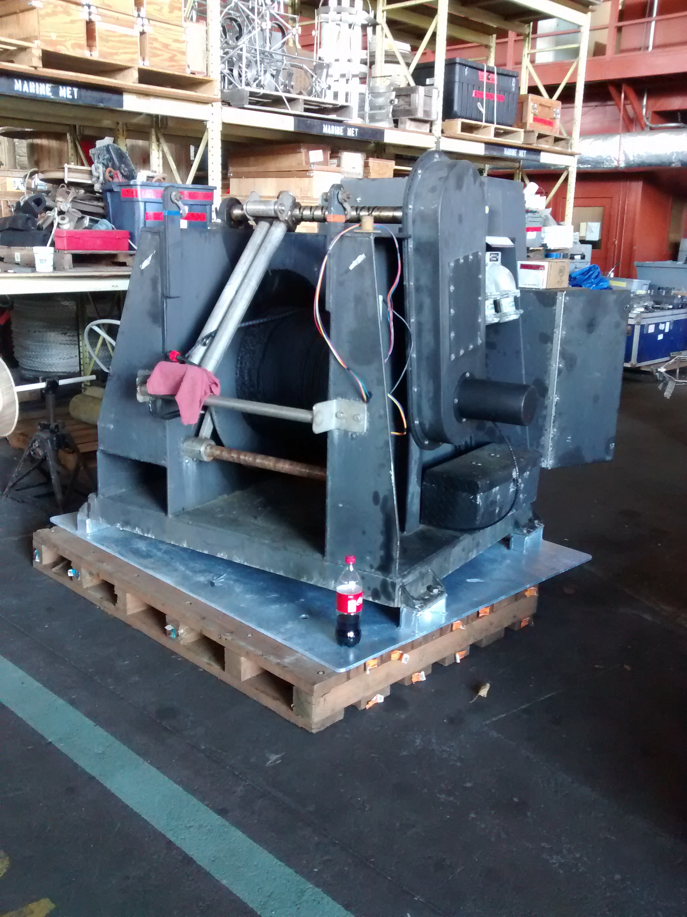

OBJECTIVE:
Tow the Acrobat behind the ship to make high-resolution hydrographic surveys as it undulates from the surface to 100 m maximum depth.

GENERAL GUIDELINES:
The Acrobat will be towed 50-100 m behind the ship from a supplied winch on deck following a predetermined course.

The tow cable length will be static when towing. Maximum tension while towing at speed will be ~1000 lbs.

As it is towed, the Acrobat will undulate or “fly” between the surface down to 100 m and is operated from the shipboard deck box on the ship.

Towing speeds will range from 5-9 knots when towing, 1-4 knots when recovering.

Operations will occur during the day and night.

STANDARD OPERATING PROCEDURES:

Before the start of the project, the survey area and waypoints will be provided to the Dyson. This may be altered during the survey to sample hydrographic features of interest.

Before deploying the Acrobat, the Acrobat operator will communicate with the Operations officer to establish and confirm a protocol for deployment, towing and recovery.

After approval from the Operations officer, the Acrobat will be deployed from the working deck using the A-frame and Acrobat winch. When the Acrobat is in the water and 10-15 from the back deck, the operator will turn the power on. The tow cable will be spooled out to a predetermined length and stopped off using rigging provided by the operator. During towing there will be no tension on the winch.

While towing, the Acrobat operator will monitor the depth of the instrument. Once deployed, the tow cable position only needs to be monitored during turns. Before executing a turn, towing speed will be reduced and the operator will bring the Acrobat to the surface. During the turn, the bridge and either a member of the crew or scientific party will monitor the angle of the tow cable to prevent fouling. After the turn is complete, the bridge will communicate with operator and sampling will continue.

Upon recovery, ship will slow down. The Acrobat operator will bring the vehicle to the surface and turn the power to the Acrobat off. The tension will be released from the stop rigging and transferred to the winch. The winch will be use to spool the two cable in and, in conjunction with the ship’s A-frame, be used to bring the Acrobat onboard.

EMERGENCY RECOVERY:

There are several scenarios that will require emergency recovery:

Complete power failure
In the case of complete power failure, which will result in the loss of control of the Acrobat, the wings will automatically reset to a neutral position bringing the Acrobat to the surface. The Acrobat can then be recovered as per the standard procedure with the A-frame and the winch.

Winch malfunction
If the Acrobat cannot be recovered using the supplied winch, the tow cable can be spooled in using appropriate shipboard equipment (e.g. winch, capstan). Before recovery, the operator will shut off power to the Acrobat to reset the wings to the neutral position, causing the Acrobat to come to the surface and reduce tension on the tow cable.

Catastrophic cable
Catastrophic failure will occur if the tow cable is severed. In this case the Acrobat will sink. The remaining tow cable is to be recovered. If deemed possible, an attempt to recover the Acrobat should be made.

Appendix III: ITAE Mooring

This is a new type of mooring that has not been previously deployed or recovered from Oscar Dyson.

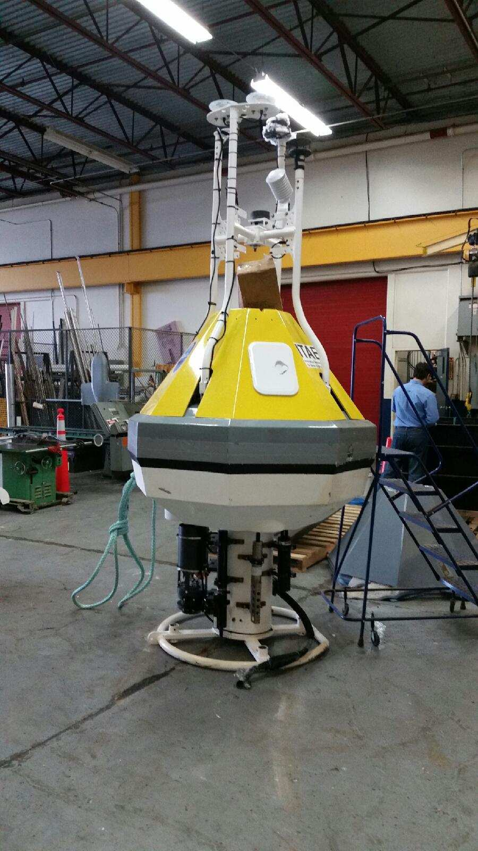

Appendix IV: Argo drifters/floats

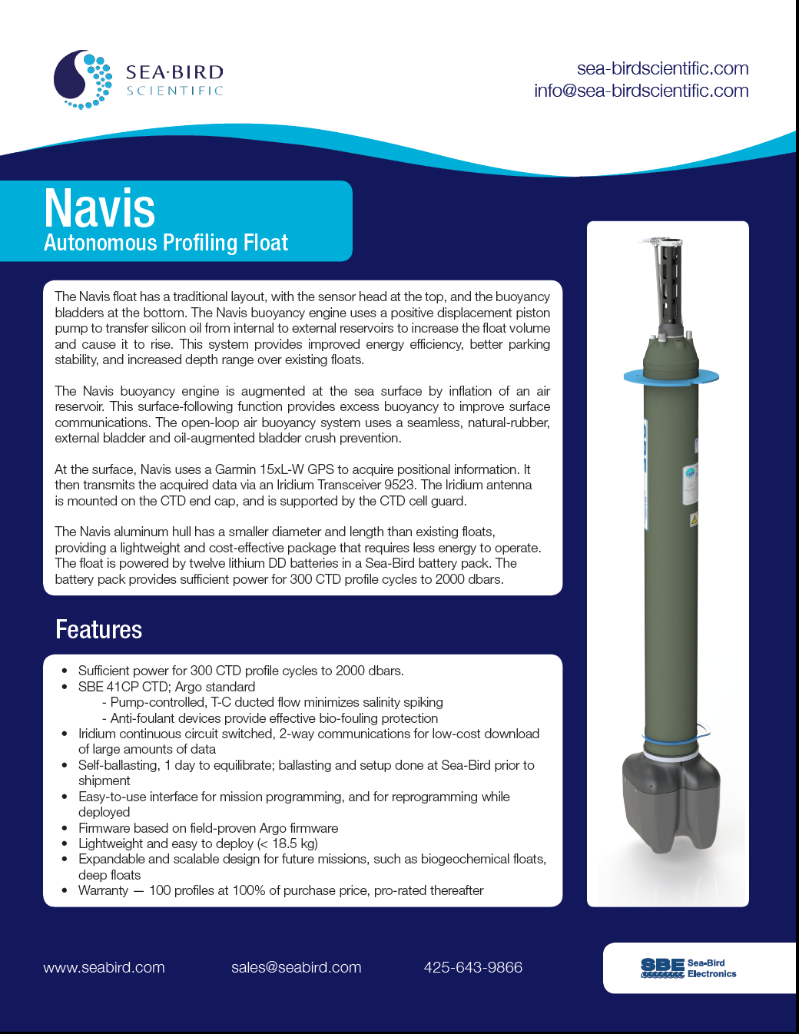
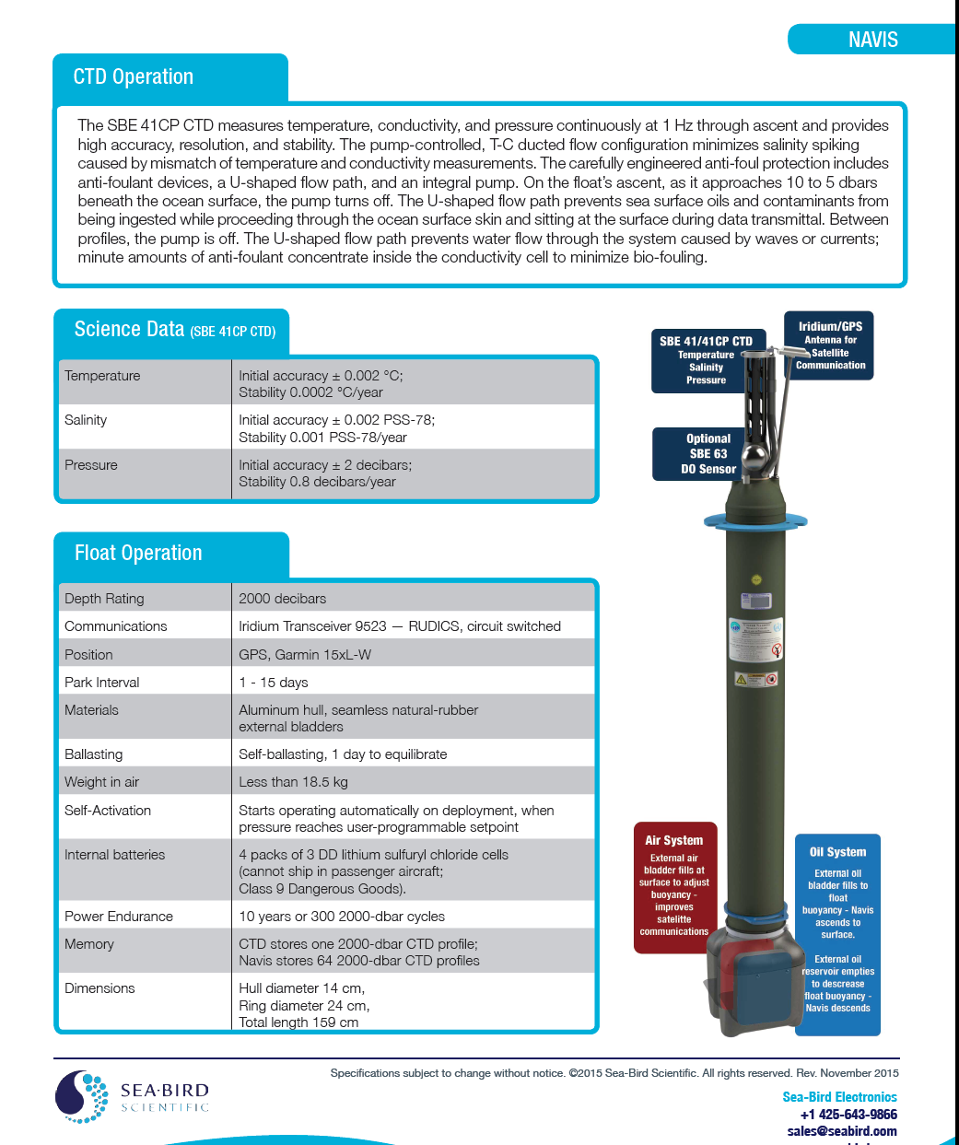

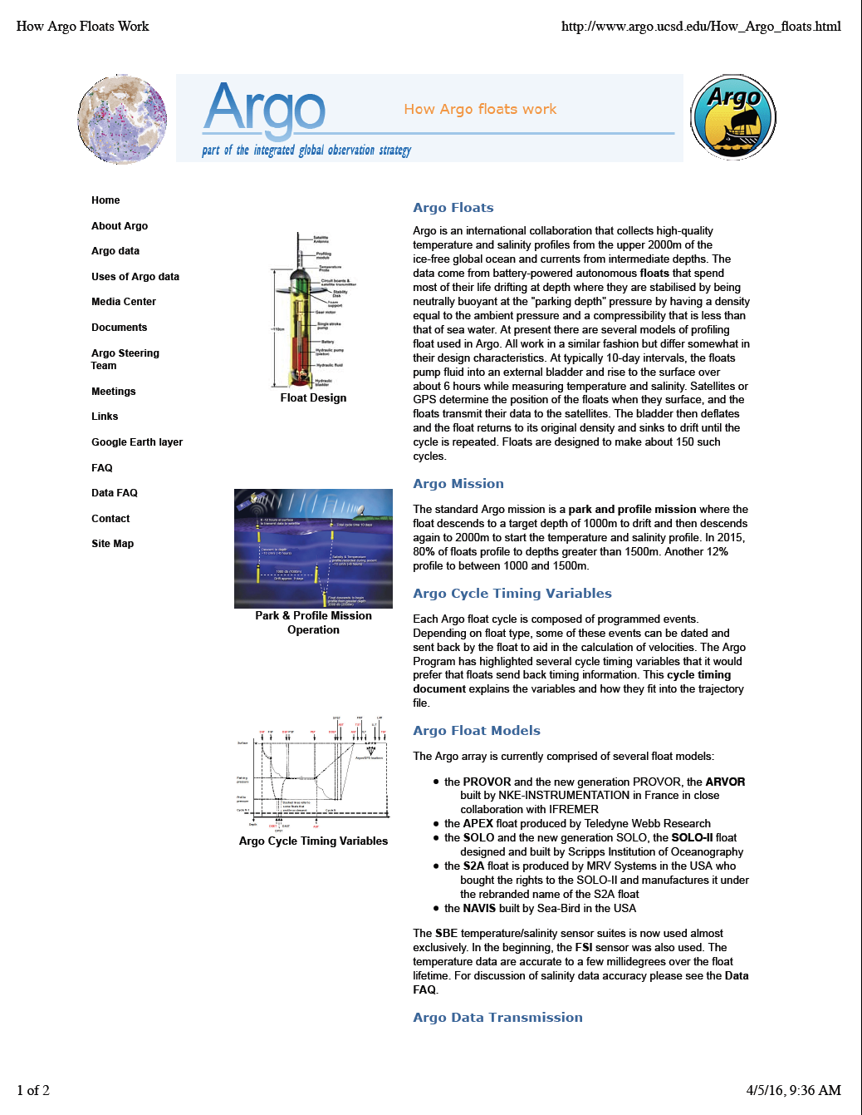

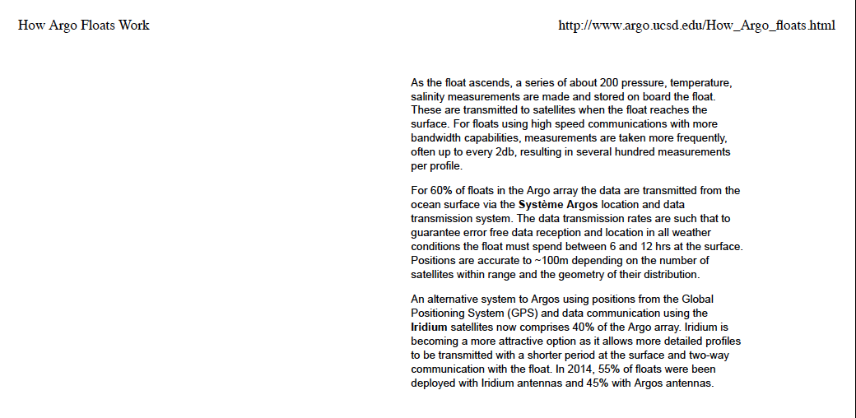

As noted above, an Argo float weighs less than 40 pounds in air. Launching is relatively straight forward with two persons handling a line fed through a hole in the collar of the float. Once the ship has come to about 1-2 knots the float is lowered over the side and the line retrieve. Position of the release is marked on the ships SCS system, usually via a button on the CTD computer. The float will self-actuate when it reaches its programmed depth.

Appendix V: Multi-net
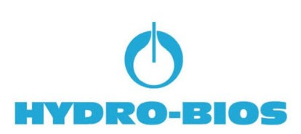

MultiNet®

Multi Plankton Sampler

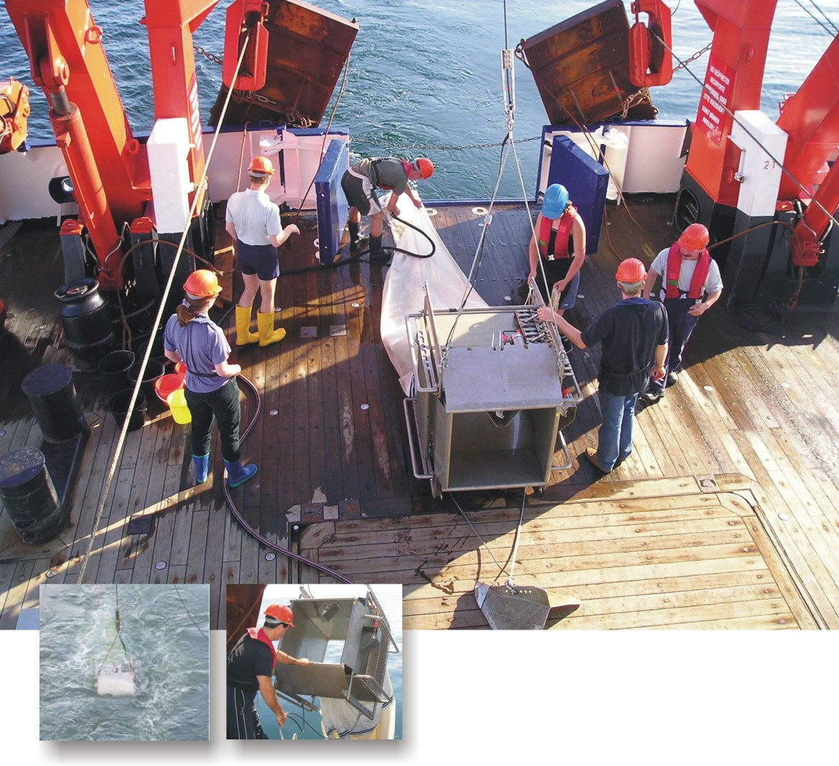

Features:

[ Combined online/offline use (standard)

[ Bi-directional communication

[ Standard depth range 3000 m

[ Long distance FSK-telemetry
(> 10000m)

[ Low power consumption

[ Battery operated Underwater Unit, max. voltage of 5 V at the conductor cable

[ Electronics operate from -40°C up to +85°

[ EC-conformity (CE) EN 50081-1, EN 50082-1

[ expandable range of sensors

phone: +49-431-36960-0 fax: +49-431-36960-21 e-mail: info@hydrobios.de web: www.hydrobios.de

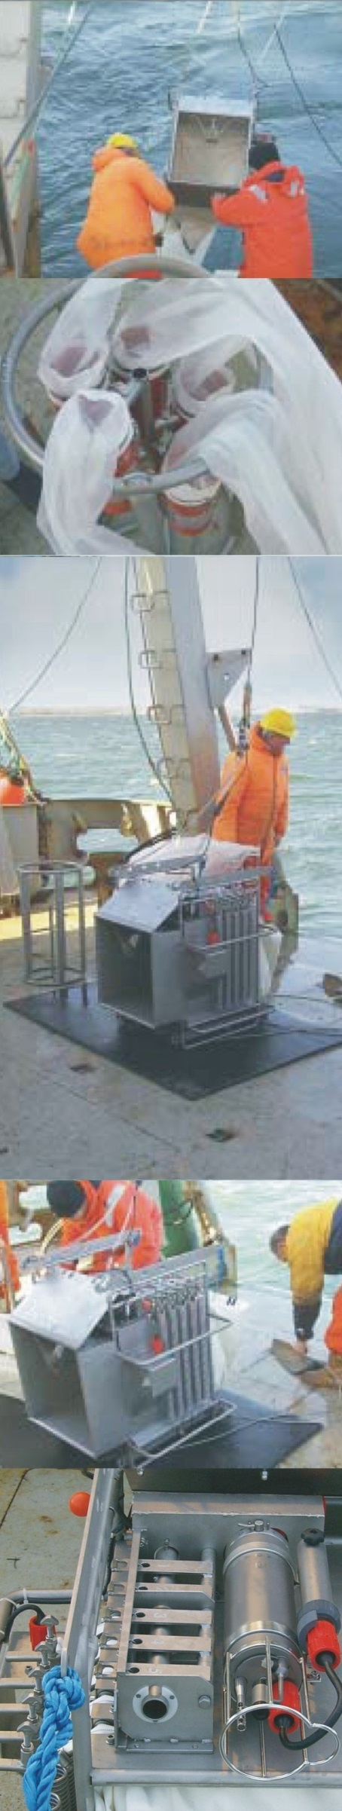

The System

Sampling sea and ocean at its best - with the improved MultiNet® generation of the Multiple Plankton Sampler, the worlds leading sampling system for horizontal and vertical collections in successive water layers.

New: for combined online/offline use

Equipped with 5 resp. 9 net bags the MultiNet® can be delivered in 4 sizes (apertures): Mini (0.125 m²), Midi (0.25 m²), Maxi (0.5 m²) and Mammoth (1 m²).

The system consists of a mains powered Deck Command Unit and a stainless steel frame with canvas part to which 5 (9) net bags are attached by means of zip fasteners. The net bags are opened and closed by means of an arrangement of levers which are triggered by a battery powered Motor Unit. The commands for actuation of the net bags are given via single or multi-conductor cable (not included in our scope of delivery) between the Underwater Unit and the Deck Command Unit.

A wide selection of mesh sizes for the net bags is available to meet the requirements of all standard and non-standard applications. For common horizontal collections a mesh size of 300 microns (mesh sizes from 100 to 500 microns available) is recommended, for vertical collections mesh sizes from 55 to 500 micron are applicable.

An integrated Pressure Sensor (measuring range according to customer’s requirements) allows continuous supervision of the actual operating depth which is indicated together with all relevant system data at the LCD-display of the Deck Command Unit.

Two Electronic Flow Meters with automatic angle compensation are mounted to the Underwater Unit: one inside the opening of the Underwater Unit for the determination of the amount of water passing through the opened nets, one outside the opening for the determination of clogging effects.

For horizontal collections the MultiNet® is used with a V-Fin Depth Depressor, to carry out vertical collections, a stainless steel support is securely attached to the bucket holder and enables a quick lowering to depth.

Operation
In its initial position the MultiNet® is brought to water with all net bags closed. The water flows freely through the frame allowing to
lower it to the greatest desired depth with high paying out speed
where the first net bag is opened by push button control from the
Deck Command Unit. At the end of the desired period of horizontal collection resp. after passing the desired depth interval in case of vertical operation, the first net bag is closed by a second command. The second net is opened simultaneously. This procedure is repeated for the remaining net bags, while the Deck Command Unit indicates the number of the active net bag. During operations of Mini and Midi versions the last net (no. 5) remains open, it collects plankton from the smallest desired depth up to the water surface. During operations of the Maxi and Mammoth versions the last net (no. 9) can be closed before reaching the water surface.

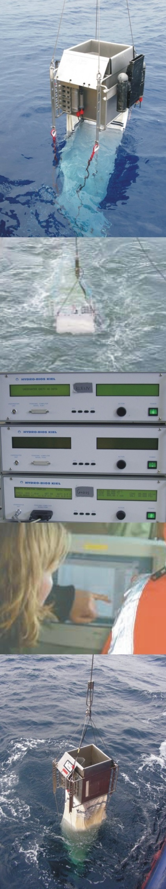
The Specialties

Offline Use
In case that a conducting cable is not available on board of the vessel, the required sampling depth can be pre-programmed via personal computer. During offline use the activation of the net bags is carried out automatically according to the pre-selected depth intervals. All measuring data are stored inside the internal data memory of 16 MByte during the operation and can be read by a PC when the MultiNet® is back on board.

Options

CT-Set
Together with the optional CT-Set the system offers the full capability of a state-of-the-art oceanographic Multi Parameter Probe. The CT-Set consists of one conductivity sensor, one temperature sensor and an additional electronics board which are completely integrated into the Motor Unit of the MultiNet®. From the CTD data the system computes salinity, density and sound velocity according to UNESCO formulas.
CT-Set for MultiNet®
Conductivity sensor: 0 ... 65 ± 0.01 mS/cm, Temperature sensor: -2 ... +32 ± 0.005°C
Data rate : 1 Hz (1 data set per second)

No. 450 500

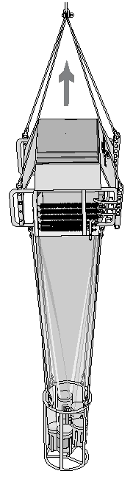
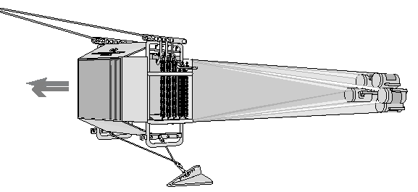

./ Additional sensors of various parameters
./ Special version for operational depths down to 6000 meters
./ Pitch and Roll sensor (standard
for the Mammoth)

